EXPERIMENT 3 – E-Commerce Mobile App Prototype (Figma)
AIM
To design a prototype for stakeholder feedback.
PROCEDURE
- Open Figma and create a new design file.
- Create a suitable mobile frame for the e-commerce application.
- Design the Home Page with the application name, search bar, product categories, and product listings.
- Design the Product Page with product image, product name, price, rating, description, quantity, and an Add to Cart button.
- Design the Cart Page to display selected products, quantity, price, subtotal, delivery charges, and total amount.
- Add a Proceed to Checkout button on the Cart Page.
- Design the Checkout Page with delivery address, payment options, order summary, and Place Order button.
- Create two different UI variations of the e-commerce application to resolve the UI design conflict.
- Modify the layout and visual design of the second variation while maintaining the required functionality.
- Use Figma Prototype mode to connect the screens.
- Connect the Home Page to the Product Page.
- Connect the Product Page to the Cart using the Add to Cart button.
- Connect the Cart Page to the Checkout Page using the Proceed to Checkout button.
- Test the complete navigation and verify that the prototype works correctly.
- Present both UI variations to the stakeholders for comparison.
- Collect stakeholder feedback and use the feedback for final UI selection and finalization.
OUTPUT:
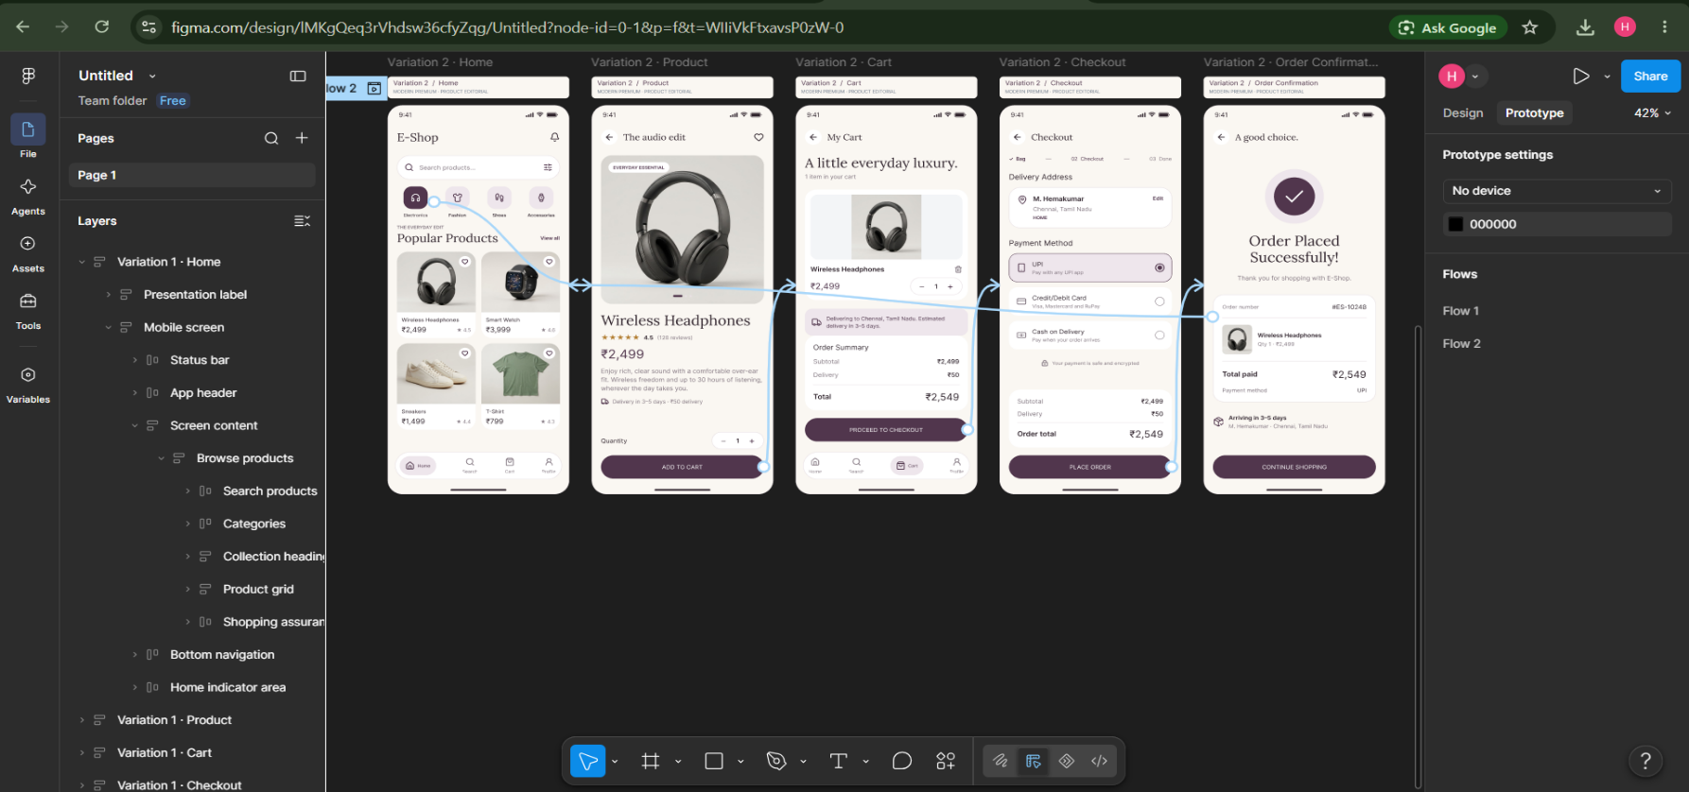
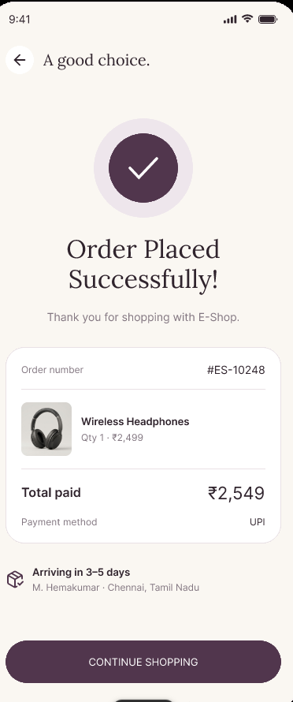
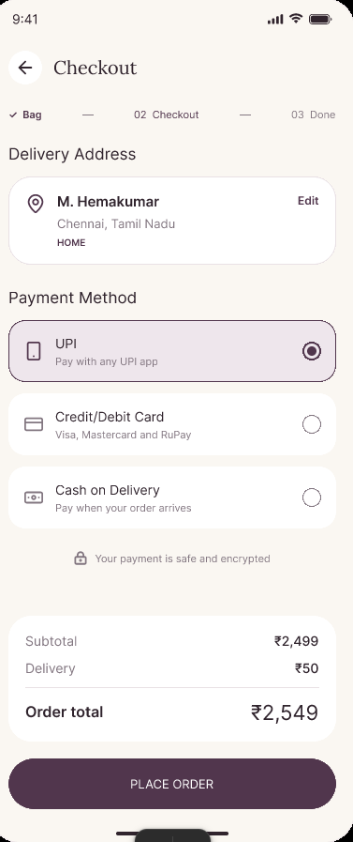
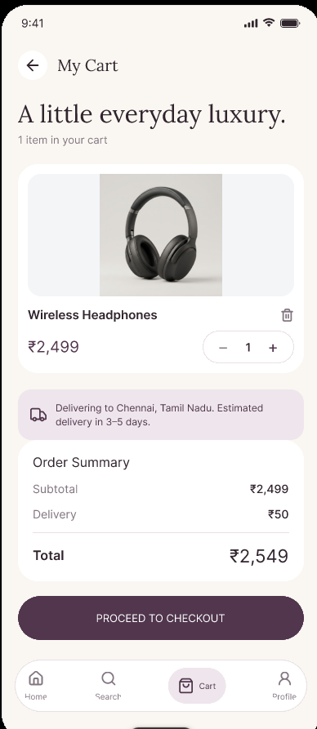
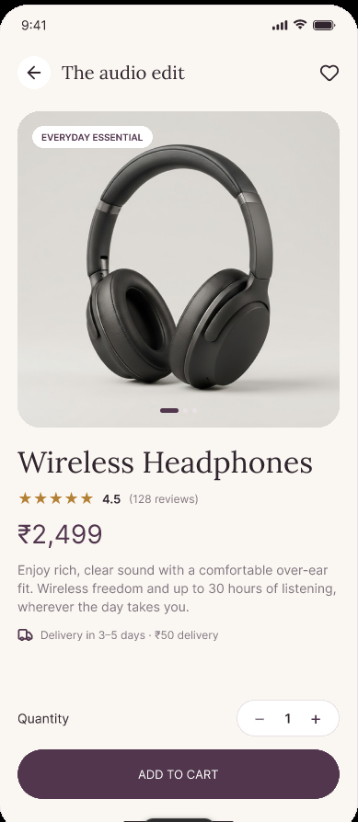
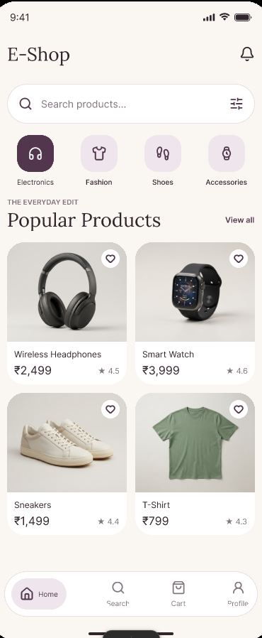
RESULT:
Thus, the E-Commerce Mobile App prototype was created successfully and stakeholder feedback was collected for UI finalization.

